Achieved: “” Not Yet Achieved: “X”
Monitoring |  | 1 | 2 |  | 3 | 4 | 5 | 6 | 7
Date
E1. Turn off lights when the room is not in use.
E2. Turn off computers and other electrical equipment (e.g. projector, microphone box, etc.) when not in use.
E3. Adopt natural ventilation (i.e. open windows and doors) and use fans when the outdoor temperature is below 25°C and the outdoor air quality is good.
E4. Maintain the temperature of air-conditioners in your classroom within the temperature range set under the school policy.
E5. When leaving the classroom, turn off fans that are not in use.
E6. Other practice:

 | Achieved: “” Not Yet Achieved: “X”
 | Monitoring | 1 | 2 | 3 |  | 4 | 5 | 6 | 7
 | Date
 | W1. Turn off the water tap and/or drinking fountain after use.
 | W2. When using soap to wash hands, turn off the water tap/remove hands from the water source (applicable to schools with infrared automatic sensing taps installed).
 | W3. Do not over water the plants (applicable to schools that have plotted plants in the classrooms or along the corridors).
 | W4. Other practice:

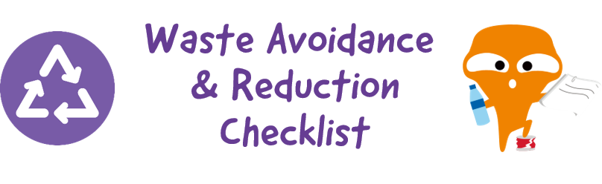
Achieved: “” Not Yet Achieved: “X”
Monitoring |  | 1 | 2 | 3 | 4 | 5 | 6 | 7
Date
Food Waste | R1. Do not produce a significant amount of leftovers.
 | R2. Separate the food waste from lunchboxes, cutlery and/or containers to facilitate food waste recycling, if any.
Paper | R3. Use less paper towel and use handkerchief/towel instead.
 | R4. Put one-side-used paper into appropriate collection box.

Achieved: “” Not Yet Achieved: “X”
Monitoring |  | 1 | 2 | 3 | 4 | 5 | 6 | 7
Date
Plastics | R6. Bring your own water bottle.
 | R7. Stop buying bottled water and/or drinks.
 | R8. Drink without plastic straw or use reusable straws when necessary.
 | R9. Use reusable meal boxes, cups, bowls and cutlery (such as spoons, forks, etc.) at school.

Achieved: “” Not Yet Achieved: “X”
Monitoring |  | 1 | 2 | 3 | 4 | 5 | 6 | 7
Date
Reuse & Recycle | R10. Use recyclables to make decorative items at school events (such as party, sports day, picnic, outing, fun fair, etc.).
 | R11. Put waste paper, metal cans and plastics into appropriate recycling bins.
 | R12. Put beverage cartons (tetra pak) into appropriate recycling bin(s), if any.
 | R13. Practise clean recycling.
 | R14. Other practice:

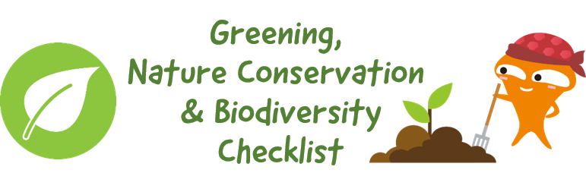
Achieved: “” Not Yet Achieved: “X”
Monitoring | 1 | 2 | 3 | 4 | 5 | 6 | 7
Date
G1. Grow and look after plants in the classroom or along the corridor, if any.
G2. Grow and look after plants in the green area/organic farm, if any.
G3. Use organic fertilisers (such as compost) as appropriate.
G4. Practise “Leave No Trace” during school outings (e.g. school picnic, visits to country parks/ geoparks, etc.).
G5. Other practice:

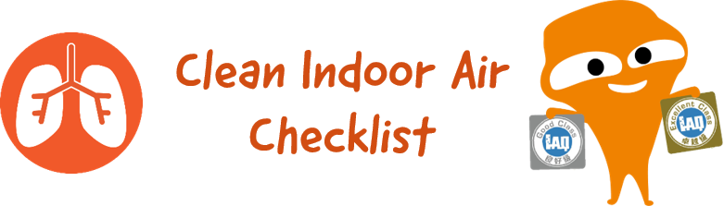
Achieved: “” Not Yet Achieved: “X”
Monitoring | 1 | 2 | 3 | 4 | 5 | 6 | 7
Date
A1. Keep the rubbish bin in your classroom clean and covered with a lid properly after use.
A2. Keep the food waste collection bins and/or composters on campus clean and ensure the lids are tightly closed after use, if any.
A3. Timely activate the air purifier in the classroom, if any.
A4. Other practice:

